STEPS

SECTION ONE:
We have to do some crunches over the mats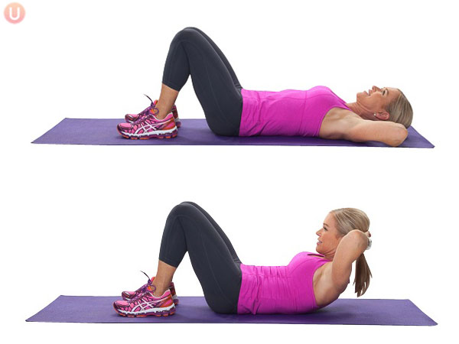

SECTION TWO:
We have to jump from bank to bank
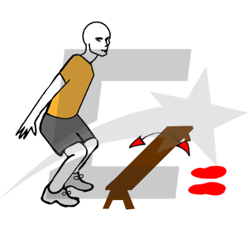

SECTION THREE:
You have to jump rope
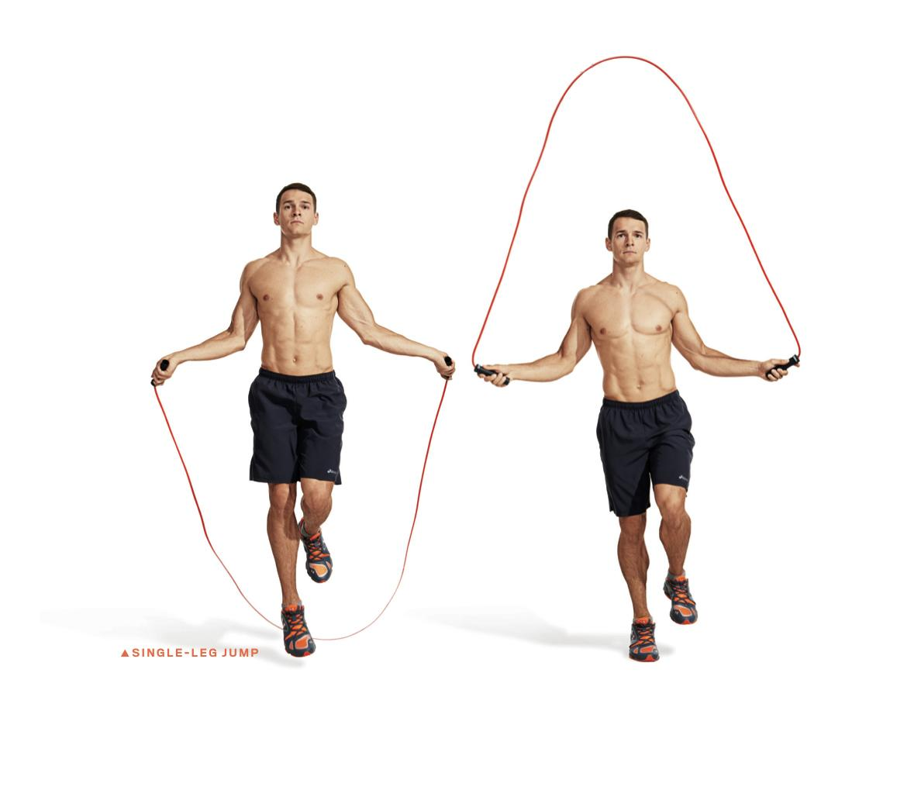
SECTION FOUR:
We have to do squats
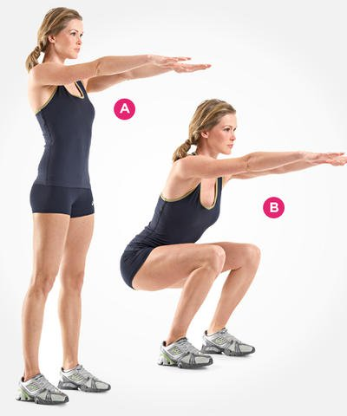

SECTION FIVE:
We have to do ironing

SECTION SIX:
We have to take the medicinal ball and throw it into the air and then take it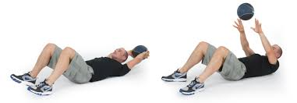

SECTION SEVEN:
Lie on the ground and raise your feet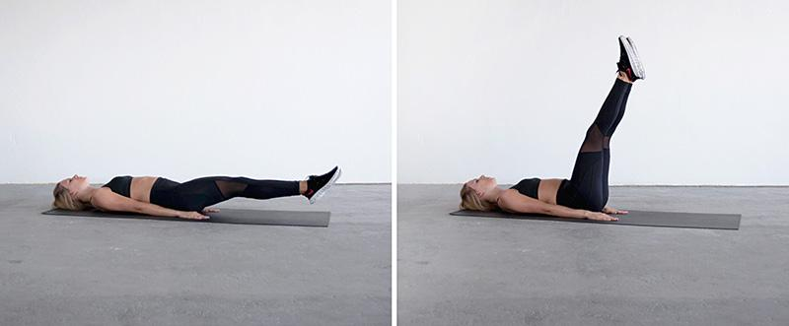

SECTION EIGHT:
You do crunches

SECTION NINE:
You have to raise the bench with one leg and the other
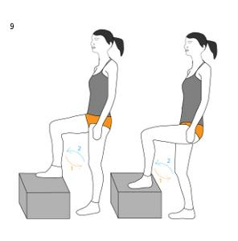

SECTION TEN:
You have to stretch on the floor and you have to raise your back

SECTION ELEVEN:
You have to stretch on the floor and raise your arms and feet up

SECTION TWELVE:
He has to stretch out on the ground and make the bicycle
